Veterans challenge speaker's credentials
By Sara Kuhl skuhl@tmnews.com | Posted: Saturday, May 16, 2015 9:15 pm
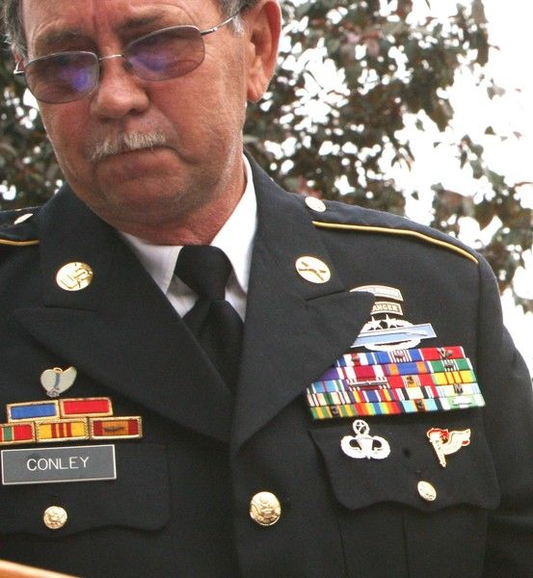

Veterans challenge speaker's credentials
Garet Cobb | Times-Mail
Many area veterans are upset about Michael Joseph Conley speaking at the welcome home ceremony for Vietnam veterans May 9. Several people allege Conley did not earn all the ribbons and decorations on his uniform.
The Vietnam War veteran who was the featured speaker at a “welcome home” event in Lawrence County May 9 has been accused of exaggerating his military record, wearing medals he has not earned and falsely claiming to have fought in battles.
Others, though, believe he earned everything he says he was awarded.

Huron native Michael Joseph Conley was invited by the Lawrence County Vietnam Veterans group to speak during the ceremony at the courthouse. Even before the event, two online sources — both run by military veterans — questioned the honors and awards Conley claims to have earned. One, a blog called “This Ain’t Hell,” posted photos from the event of Conley in a military uniform and medals he wore that day, referring to it as a “clown suit.”
Conley, who now lives in Georgia, denied comment when called. He has received similar criticism, and dismissed it, in the past. He has said the military records do not accurately reflect his rank and his record, and he has been working to correct them.
Medals at issue
One of the more controversial awards Conley wore at the May 9 event was the Combat Infantry Badge with two stars, which signifies he earned the award three times. That award, along with silver stars (Conley says he earned two of those) and purple hearts (Conley has said he earned three and wore one on May 9) are all protected under the Stolen Valor Act of 2013. The Stolen Valor Act makes it a federal crime to fraudulently claim to be recipient of certain military medals, with the intent to profit or gain tangible benefits.
According to Army regulations, second and third awards of the Combat Infantry Badge are “indicated by superimposing 1 and 2 stars, respectively, centered at the top of the badge between the points of the oak wreath.” Separate awards of the CIB have been authorized for qualified soldiers who served during:
• World War II (1943-1945).
• The Korean War (1950-1953).
• The Vietnam War (1961-1973), combined with qualifying service in Laos; Dominican Republic; Korea on the DMZ; El Salvador; Grenada; Joint Security Area, Panmunjom, Korea; Panama; Southwest Asia Conflict; and Somalia, regardless of whether a soldier has served one or multiple tours in any or all of these areas. The Republic of Vietnam Conflict Era officially ended in March 10, 1995.
• What has become known as the “war on terrorism” (Afghanistan, Operation Enduring Freedom) and (Iraq, Operation Iraqi Freedom).
That means Conley would have had to serve in Korea to earn the first award, Vietnam for the second award and either Iraq or Afghanistan after 2001 for the third award.
“Only 325 have been awarded,” said retired Master Sgt. Jeff Hinton of the United States Army and a Green Beret. “They’re legends. ... You don’t see them very often, and Conley is not one of those individuals.”
Hinton operates the website “Professional Soldiers,” a clearinghouse for people looking into military fraud. For the past 10 years, he has been exposing people who falsely claim the title of Green Beret if they use that title for any sort of profit or fame.
On Oct. 23, 2012, an exhibit at the National Infantry Museum was unveiled with the CIB recipients’ names, and Conley’s name was not among them.
Hinton also questions whether Conley was part of the infantry in Vietnam. Conley’s military records, released through a Freedom of Information Act request, list him being deployed as a wheeled vehicle mechanic in Vietnam. Three times, the words “wheeled vehicle mechanic” have been marked out and the word “rifleman” written to the right of them.
“What he has done is he’s salting his records,” said Hinton. “He has falsified his record for decades.
“‘Rifleman’ is not protocol,” Hinton said. In the 1960s, when Conley was in Vietnam, soldiers would carry their military records, but the records would not have had a line striking through the soldier’s job description. And the proper description is “infantryman,” not “rifleman.”
Hinton explained there’s nothing substantial to back up Conley’s claims of silver stars, nothing on official government websites, no press releases saying he’s earned awards. In the past, Conley has said he’s misplaced citations and paperwork declaring the awards. Hinton disputes that explanation.
“If he’s handwriting it in, he’s never seen a clerk,” Hinton said. “There’s nothing handwritten in my record.”
Of his own records, he said, “Mine are perfectly put together.”
It wasn’t until Conley was announced as the keynote speaker in last week’s ceremony that Hinton started investigating him. Hinton alleges that Conley is “a fraud.”
As another example, he points to Conley’s Facebook profile picture, showing him wearing a Green Beret hat. In an article “From Vietnam to Iraq: Canton man recounts his 42 years with the Army,” published by the Cherokee Ledger-News in Georgia, Conley said he was part of Company B of the 11th Special Forces group of the Green Berets. But the emblem on the hat signifies a Green Beret of the 10th Special Forces group.
“It disgraces everyone in uniform,” Hinton said. “It’s disrespectful ... that you have this fraud running around ... and they’re getting money and stuff from it.”
‘Preposterous’
But Commander Terry Sorrells of the Lawrence County Vietnam Veterans group disagreed.
Sorrells organized the ceremony last week with help from others. He also consulted Brad Bough, the veteran services officer for Lawrence County.
“I invited (Conley),” Sorrells said. “I asked him because I believed Mr. Conley to be exactly what he said he was, and still do.”
Hinton had contacted Sorrells before the event about inconsistencies in Conley’s records. Sorrells said he talked to Conley about it, asking for documents. Conley provided documents for Sorrells, and he told Sorrells he didn’t want to talk at the event.
“He did tell me no, that he didn’t want to discredit veterans,” Sorrells said. “We still wanted him up here.”
Undisputed facts do remain about Conley’s time with the Army: He was deployed in Vietnam, he did receive a Soldier’s Medal for saving a man’s life in 1967, he was a Ranger with the U.S. Army and later an instructor for a Ranger camp in California and more.
And it’s not uncommon for a veteran’s military records to not be totally accurate, according to Sorrells.
“No one knows more than him how messed up his records are,” said Sorrells.
Conley served in Vietnam and is a veteran of the war, and prior to 1993, if a soldier worked as a support staff for a Green Beret unit, even as a cook or mechanic, he could still wear the Green Beret hat.
“We didn’t see anything out of place or out of order,” Sorrells said. “We’re not experts, but it didn’t look different than any other person’s records.”
Sorrells stressed that Conley, who is from Lawrence County, was qualified to talk at the event. He brought up the concerns with the veterans group, and they voted unanimously to still feature him at the event. Brad Bough refused to comment.
“Conley is a Lawrence County native, and we consider him one of our own,” Sorrells said. “With two tours of duty in Vietnam and the medals that he has been awarded, we felt him to be worthy of speaking at our event.”
“I don’t care if he was a Green Beret or not. I told him to, ‘Just come up and talk to us.’ He didn’t say anything about his awards or being a Green Beret Saturday. ... He talked about love and happiness and forgiveness.
“We’re satisfied. Really, I don’t care if he wore a purple ball cap or a Green Beret. We thought everything worked all right. These allegations are preposterous.”
Sorrells said the expenses for the May 9 event were not paid from tax money, but by a private individual’s donation.
Conley served two tours in Vietnam, according to Sorrells, though the military records reflect only one deployment to Vietnam. Additionally, in previous articles published in the Times-Mail and the Cherokee Ledger-News, Conley talked about fighting in two battles in Vietnam — the Battle of Bloody Ridge and the Battle of Hamburger Hill, both in 1969. His records, however, show that he was deployed in Vietnam from Oct. 10, 1967 to Nov. 26, 1968.
Updated military records verified with the National Personnel Records Center in St. Louis, Mo., are at local attorneys’ Steele & Steele’s office at the Chase Bank building, 16th and I streets.

